Scratch Project 1
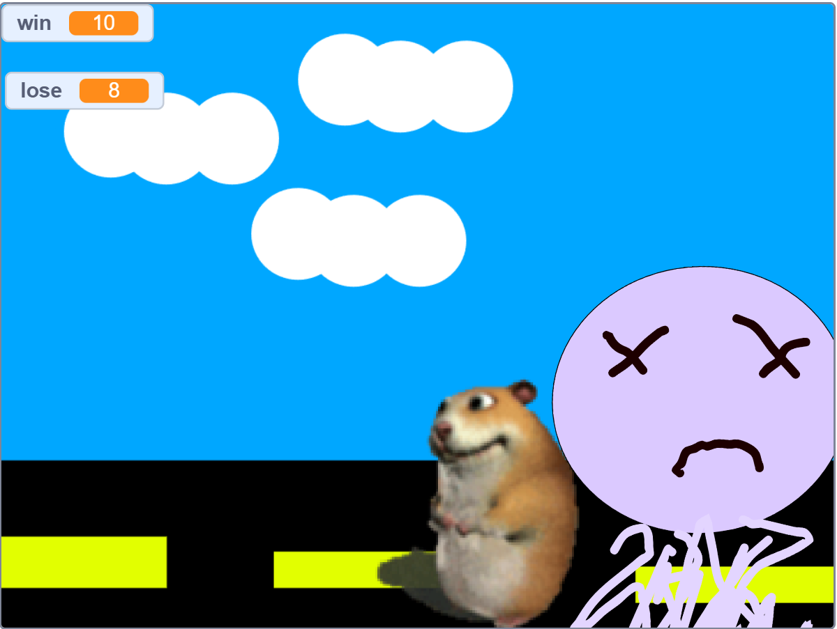 | This is my first ever scratch game, made when I was 8  Concept: Jump over obstacles  Goal: Win 100
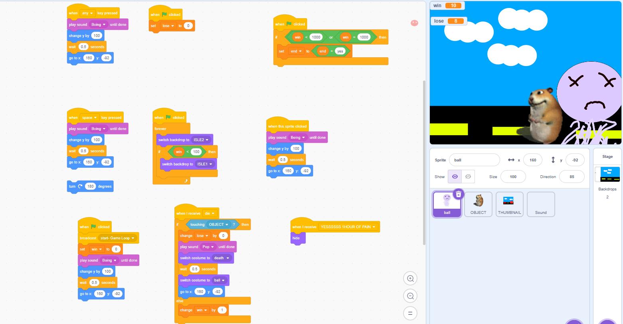 | Design: 4 objects
 | Learning: Learnt the basic categories Motion, looks, sound, variables, operators.

Scratch Project 2
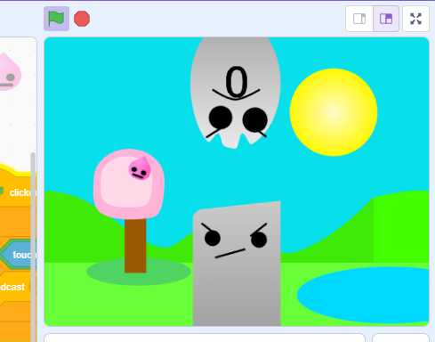  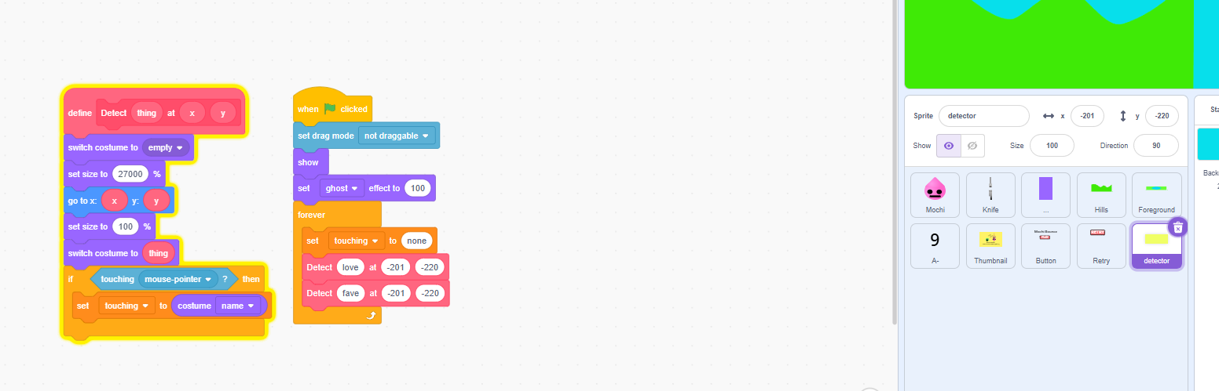 | This is the next big scratch project,  Age: 10  Concept: Flappy bird  Goal : To jump over 100 obstacles.
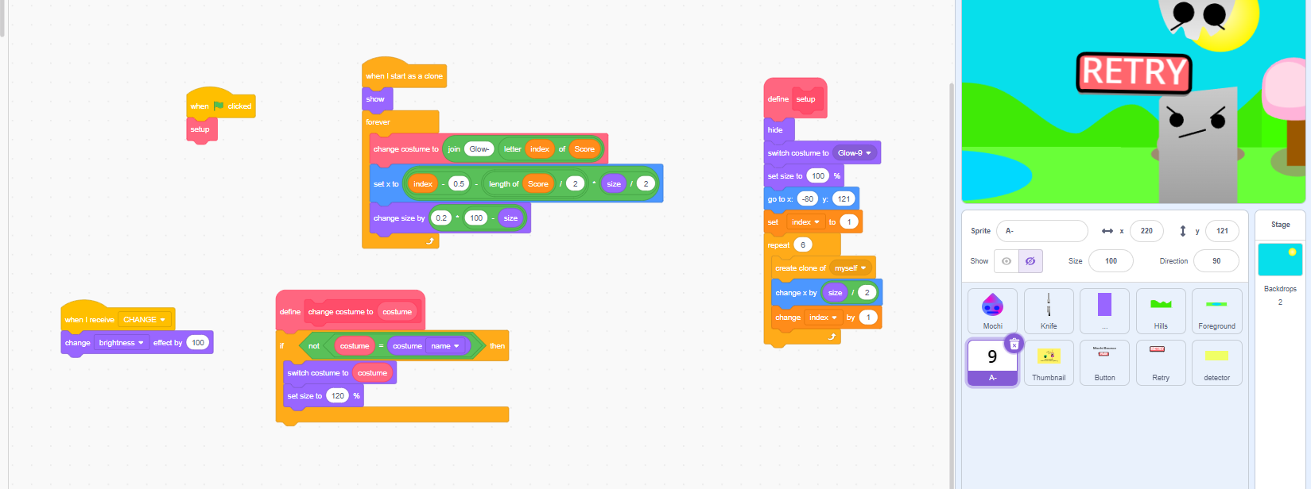  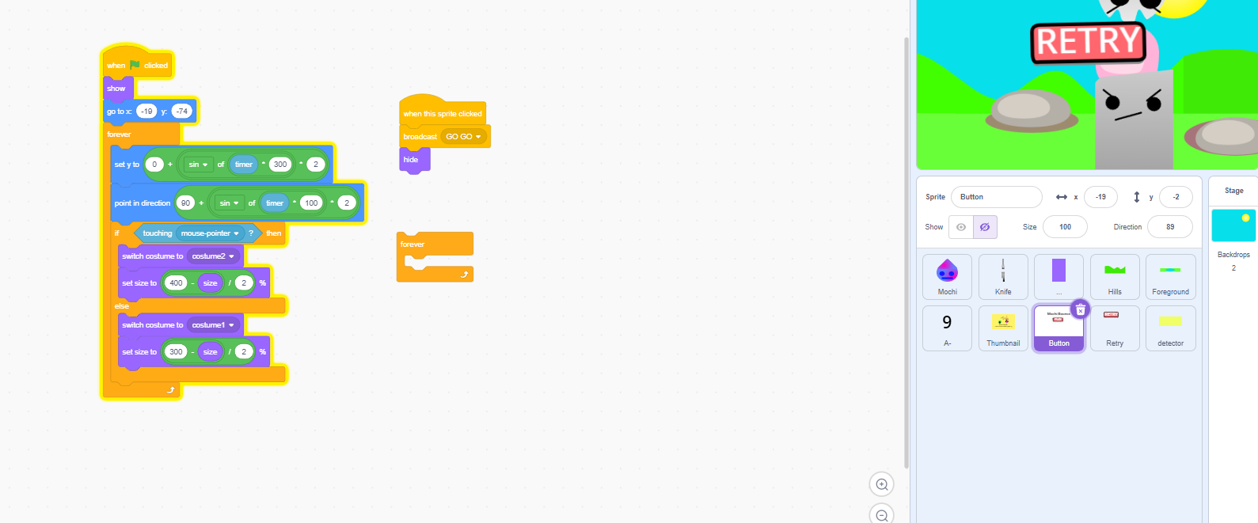 | Design:  - Player  - Pipe (Or in this case, fork)  -A collider for the pipe  -Start UI  -Retry UI  -Scrolling background  -Counter (amount of objects that have been passed)
Learnt:
-How to use broadcasts for game-loops (handy for retry UI)
-Implement UI into the game, Start, Retry button
-How to use manipulate clones (to create a scrolling bg)
-How to use functions

Scratch Project 3
<screenshot1> + text

